Detailed instructions for obtaining approval for moonlighting opportunities are now available to your trainees on MedHub (Moonlighting Information folder in the Resources/Documents section on the right hand column of the MedHub home page).
After the Program Director and GME approvals are obtained, departments may proceed with the necessary EDB action to pay the trainee. Please refer to the instruction document, also posted in the Resources/Documents section, for details about this process. If you are not the administrator responsible for EDB in your department, please share these instructions with the appropriate administrator. Miranda Tse in DGSOM Human Resources is the point of contact for questions about stipends available for trainees involved in internal moonlighting (mtse@mednet.ucla.edu; x4-3339).

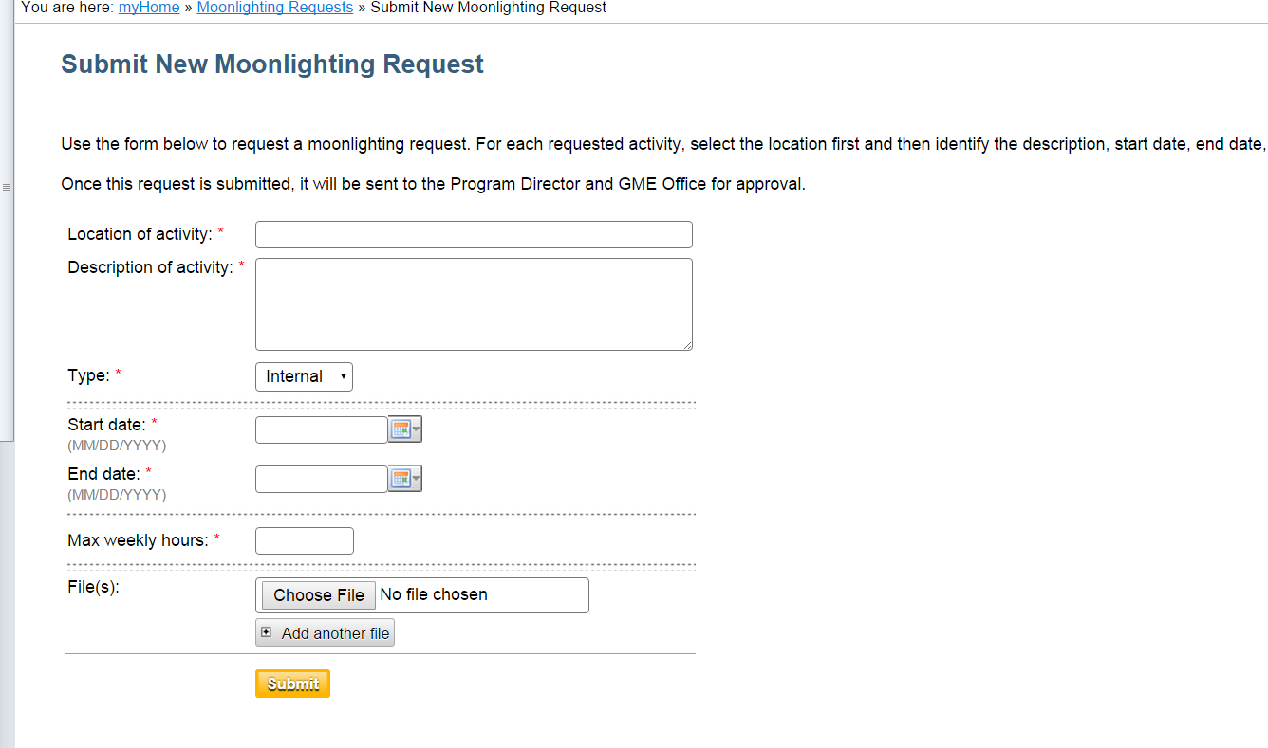
- Resident completes form (open, save as PDF, fill in requested information, including “signature acknowledgement”), saves form.
- Resident selects “Moonlighting Requests” and enters the information on MedHub – minimal (location, brief description, inclusive dates and max hours/week they anticipate moonlighting), uploads completed form. NOTE: REQUEST DATES MUST BE WITHIN CURRENT ACADEMIC YEAR.
- Request with attachment then goes to Program Director who will see a “New Moonlighting Request” in the URGENT TASKS BOX. The PD selects the link to view the request – open and review the form to verify completion, accuracy, eligibility, etc.
- PD approval prompts GME Director to review, then approve or reject. GME checkpoints include max hours/feasibility, complete form, etc. GME cannot view the request prior to Program Director approval.
NOTE: Hours worked in moonlighting activities must be logged as duty hours in the Resident Duty Hours timesheet. Trainees do this by selecting “Moonlighting” in the grey hours drop down box:
